First Latin-American Workshop on biobeds
"Biobeds to minimize contamination with pesticides - An opportunity for Latin America and its environment"
The first Latin-American Workshop on biobeds entitled "Biobeds to minimize contamination with pesticides - An opportunity for Latin America and its environment" was held 2-4 May 2012 in Pucón, Chile. It was organized by the Universidad de La Frontera, Temuco, Chile; JTI - Institute for Agricultural and Environmental Engineering, Sweden, INIA, Instituto de Investigaciones Agropecuarias, Chile, and Bayer CropScience. The purpose of the meeting was to bring together researchers, experts and authorities interested in the development of biobeds. The biobed was developed in Sweden in the 1990s and is designed to be simple and inexpensive and to collect and degrade spills of pesticides. Pesticides are often handled at a specific location on a farm with close access to water, for example, on a courtyard. If a pesticide spill occurs on the courtyard, a place where the topsoil has been removed and replaced by a layer of gravel and sand, there is a clear risk of contamination of surface- and ground waters. The use of biobeds can drastically reduce the risk of such pollution. The biobed is composed of 60 cm deep pit in the ground with a clay layer in the bottom, a biomix consisting of straw, peat and topsoil (50:25:25 vol %) which fills the remaining 50 cm, and a grass layer covering the surface. The biomix composition is designed to increase pesticide binding and microbial degradation processes. The biobed also has a driving ramp for the spraying equipment. The idea is that all handling during filling of the pesticide into the spraying tank is made on the biobed, so that spillages are bound and degraded. Biobeds have generated interest in other countries (eg England, Belgium, Italy, France, Peru, Chile and Guatemala) and its introduction has sometimes led to modifications of the original design to what is called biofilters, biomassbed, Phytobac ®, biobac and biotables.
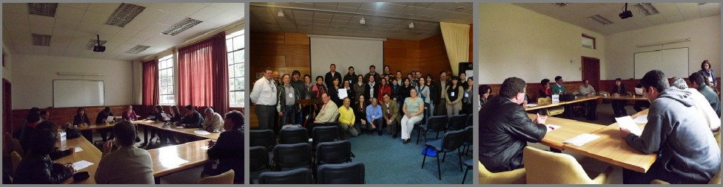
Picture from www.lechosbiologicos.cl
At the workshop presentations were given on biological techniques for pesticide degradation; optimization of biomixtures, biobed microbiology and experiences of biobeds at pilot and field scale. More than 50 presentations were given by participants from Argentina, Brazil, Chile, Colombia, Ecuador, Guatemala, Mexico, Uruguay, Venezuela, Spain, France, Germany, Denmark and Sweden. The workshop also included a visit to the first large-scale experimental biobed in Latin America built by INIA in Chile. One interesting result of the workshop is that an Iberoamerican Biobed Network (REILBI) was formed with the aim to promote interdisciplinary work in the field, to disseminate research and knowledge on biobeds through events, meetings and exchanges of researchers, and to generate knowledge that is tailored to the Latin American reality. The second workshop will be held in 2014 in Guatemala and the third in Brazil 2016.

María del Pilar Castillo and Cristina Diez
Friday, 15 June, 2012

